MCT344- Industrial Robotics

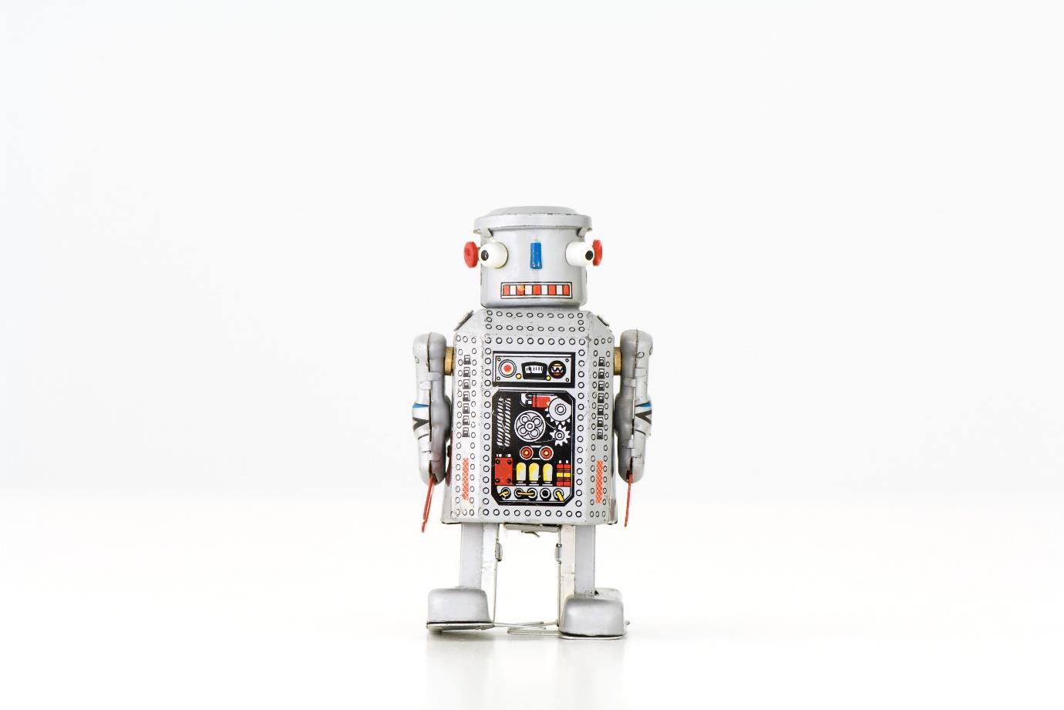

TEAM 15

Supervised by:

Dr. Shady Ahmed Maged

Dr Diaa Emad

Eng. Mina Yousry

**Submitted by:**

Kirolos Thabet Fouad 19P6754

Omar Mahrous Eltoutongy 19P1060

Table of Contents

Introduction: 3

Screenshots of code: 3

1. Position node: 3

2. fkine node: 4

3. ikine node: 5

Screenshots of the outputs: 9

RQT Graph: 11

Links: In this link, you will find our video for this milestone. 11

References: 11

Table of Figures:

Figure 1: position node 3

Figure 2: fkine node part2 4

Figure 3: fkine node part1 4

Figure 4: fkine node part3 5

Figure 5: Joint_states details 5

Figure 6: ikine node part 2 6

Figure 7: ikine node part 1 6

Figure 9: geometrical explain p1 7

Figure 8: geometrical explain p2 7

Figure 10: geometrical explain p3 8

Figure 11: Rostopic list 9

Figure 12: topic echoing robot pose 9

Figure 13: robot after published the required position 10

Figure 14:reading the position to compare with the target position node. 10

Figure 15: sending the calculated angles from the ikine node. 10

Figure 16: RQT graph 11

# Introduction:

Project Milestone 2 is a robotics project where each team is required to submit a working package named **open_manipulator_custom_kinematics**. The package consists of two nodes, **fkine_node** and **ikine_node**, that perform forward kinematics and inverse kinematics calculations, respectively, for a robot. The project involves using DH parameters and geometric methods to calculate joint angles and transform matrices and publishing them on specific topics in Gazebo. The robot can be controlled using a GUI controller to verify the accuracy of the calculations.

# Screenshots of code:

## Position node:

This node is responsible for holding the target goal values and publish it to a topic named target_goal which the ikine node subscribes to it.

Figure 1: position node

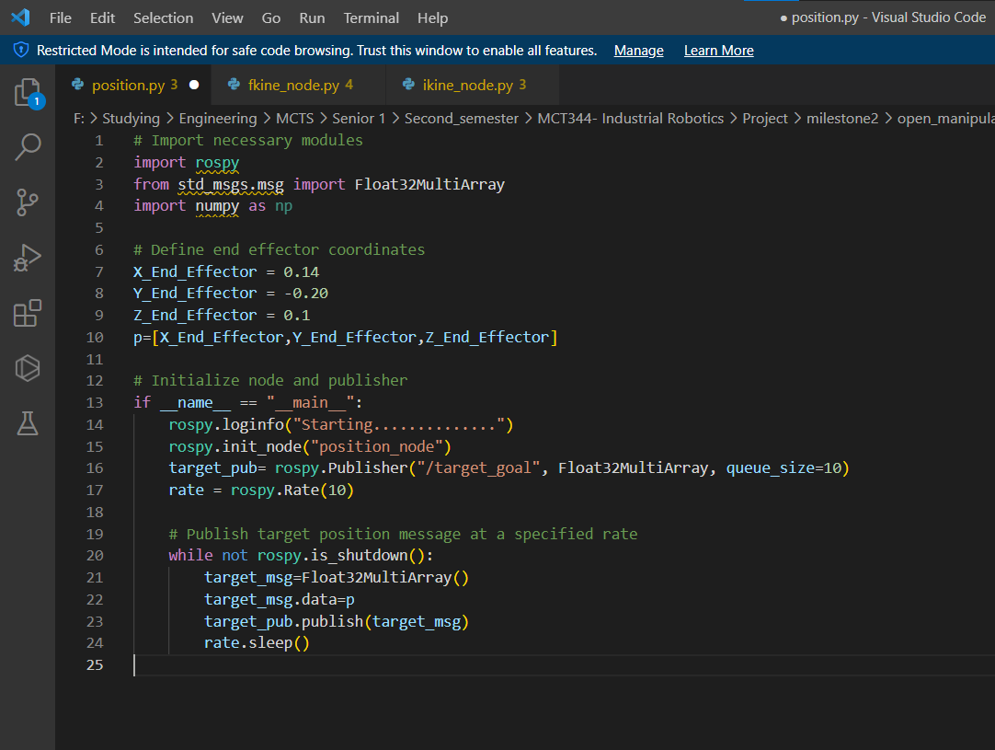

## fkine node:

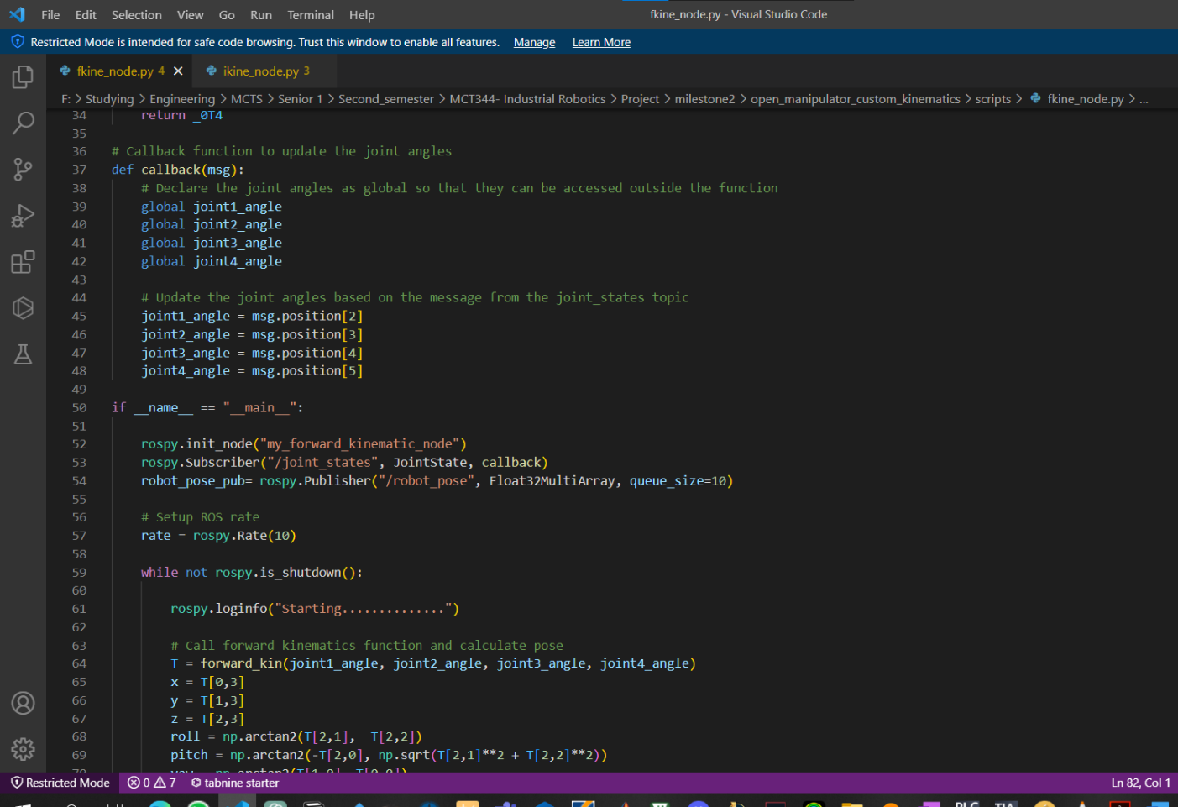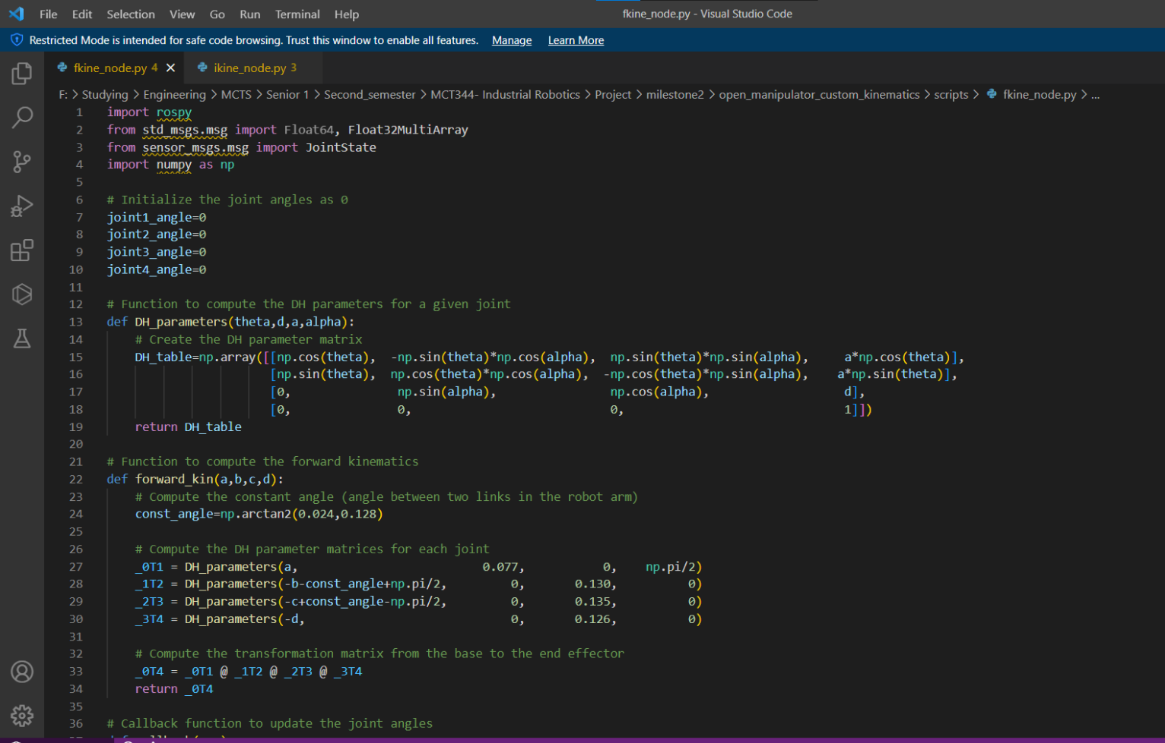this node read the angle values from the gazebo topic Jointstates and do the regular algorithm to calculate the position of end effector in Euler form.

Figure 2: fkine node part2

Figure 3: fkine node part1

Figure 4: fkine node part3

Figure 5: Joint_states details

## Text Description automatically generatedikine node:

this nodes subscribes to only one topic which is the target_goal and publishes to the 4 jointstate/command topic which are connected to gazebo to move the robot, its accuracy may be checked using the gui and we found that the maximum error in our calculations is about 0.02 , we can guess the problem which is the shifting in the axis in gazebo (small but considerable).

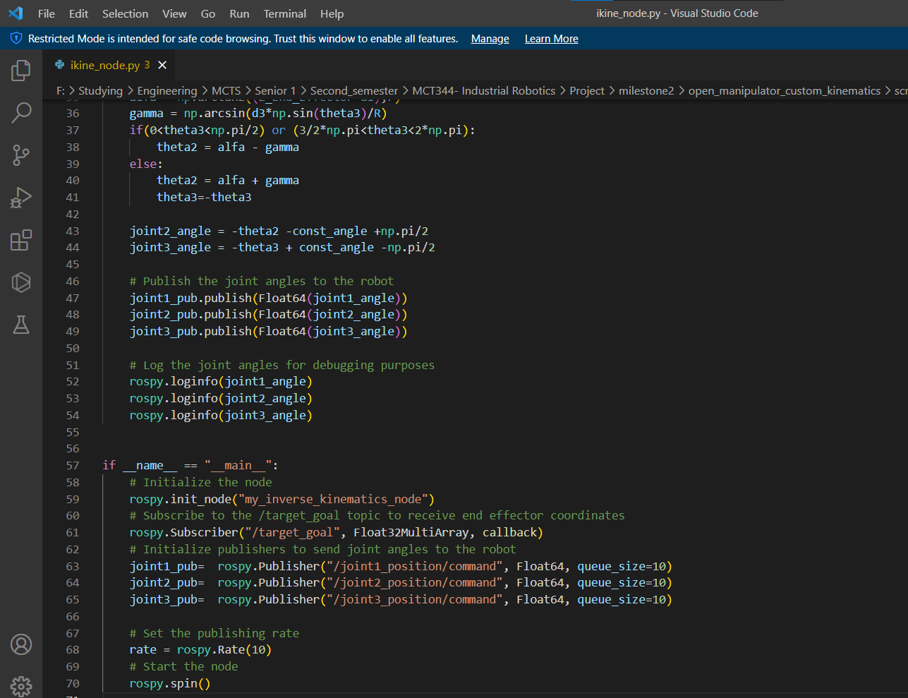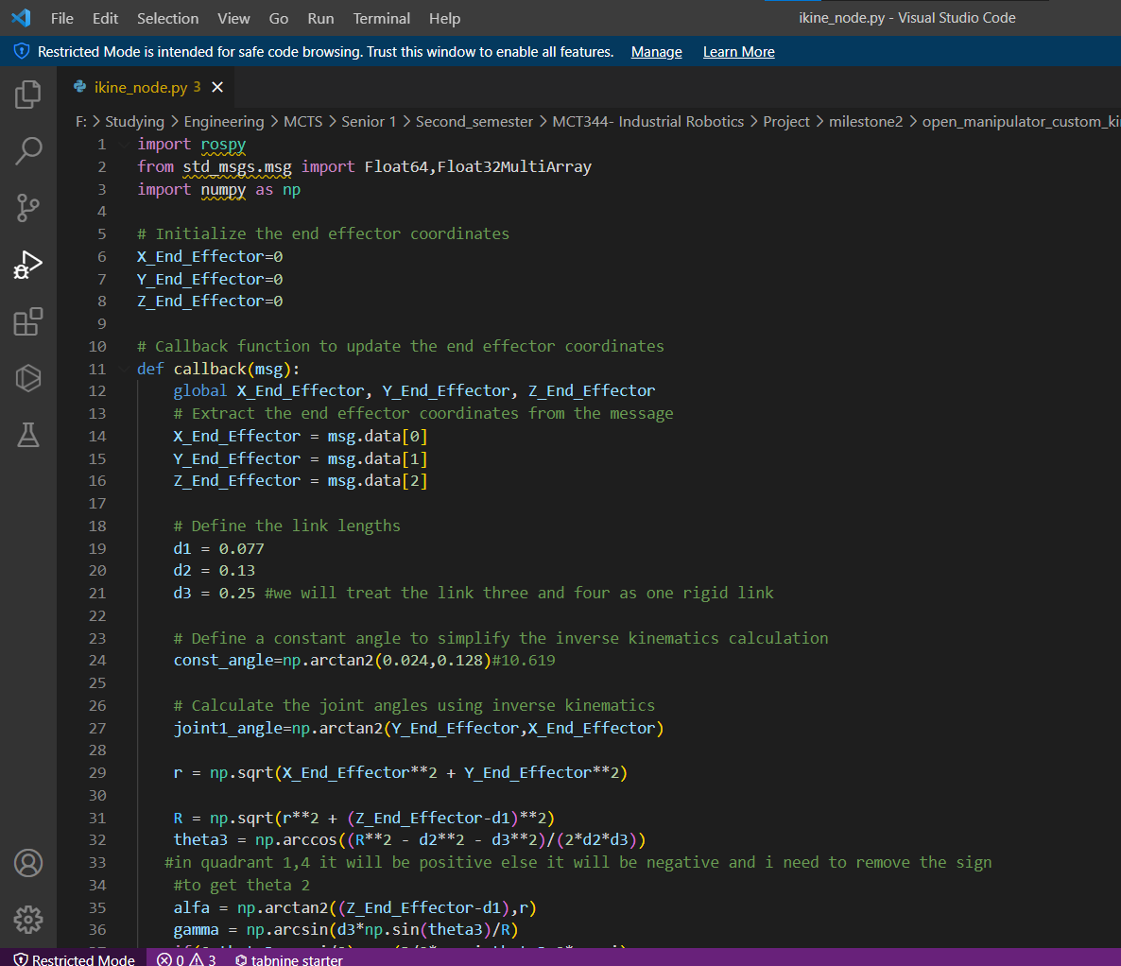

Figure 6: ikine node part 2

Figure 7: ikine node part 1

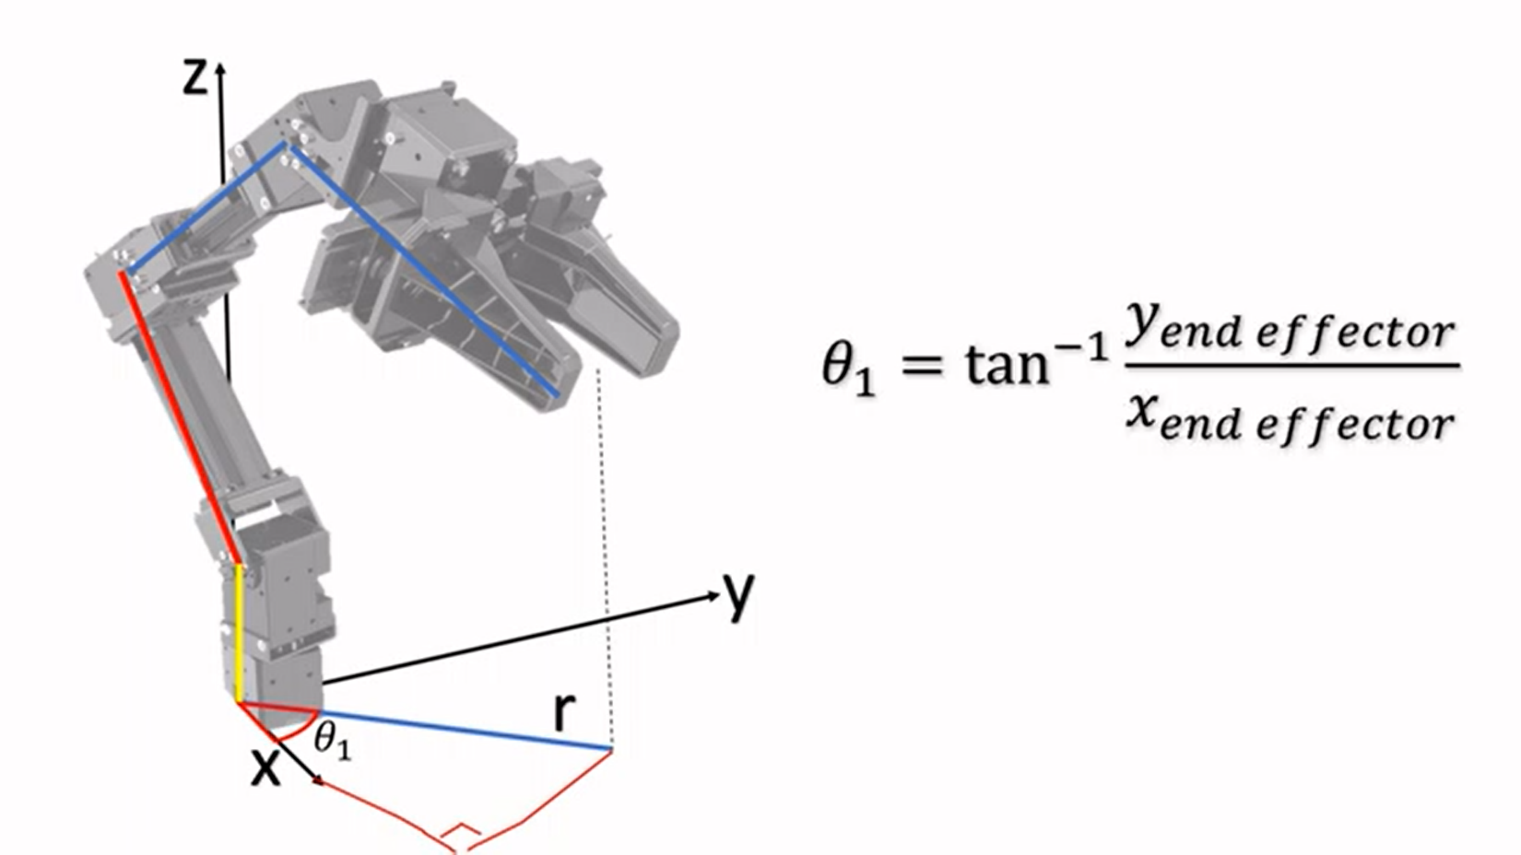

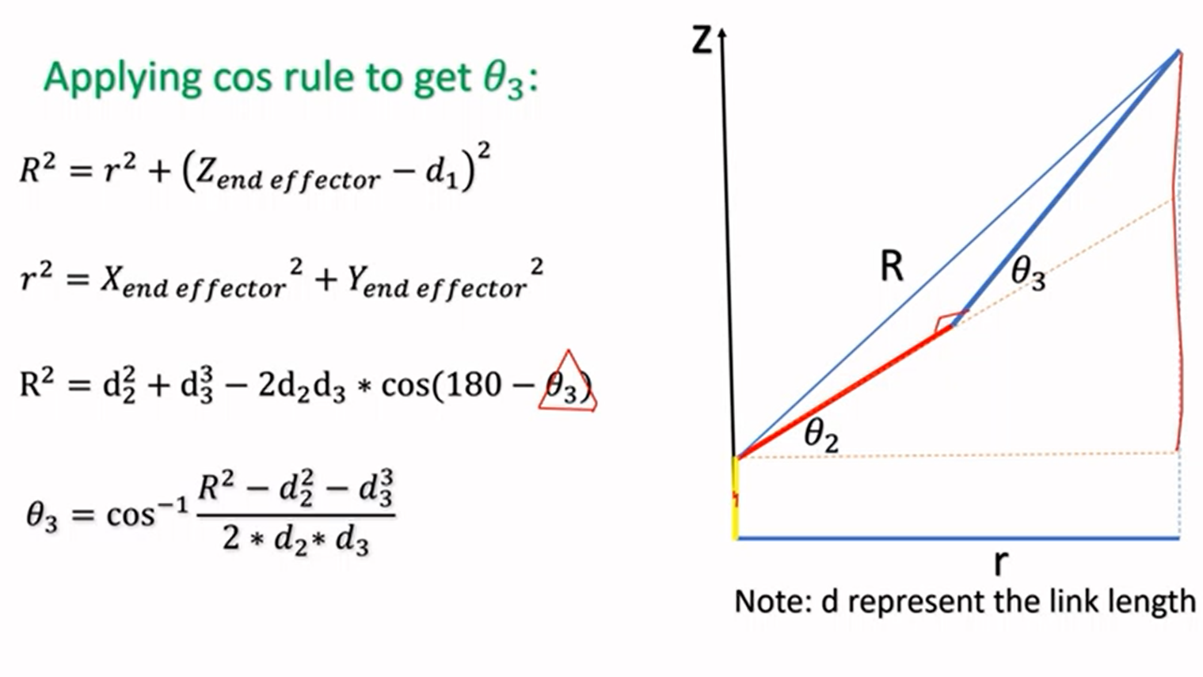Figure 9: geometrical explain p1

Figure 8: geometrical explain p2

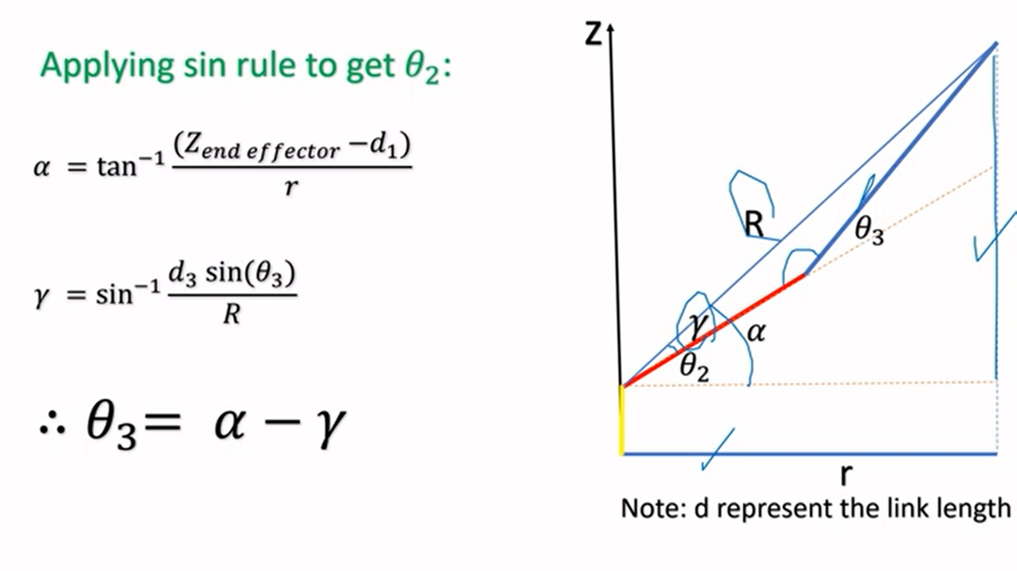

Figure 10: geometrical explain p3

# Screenshots of the outputs:

Figure 11: Rostopic list

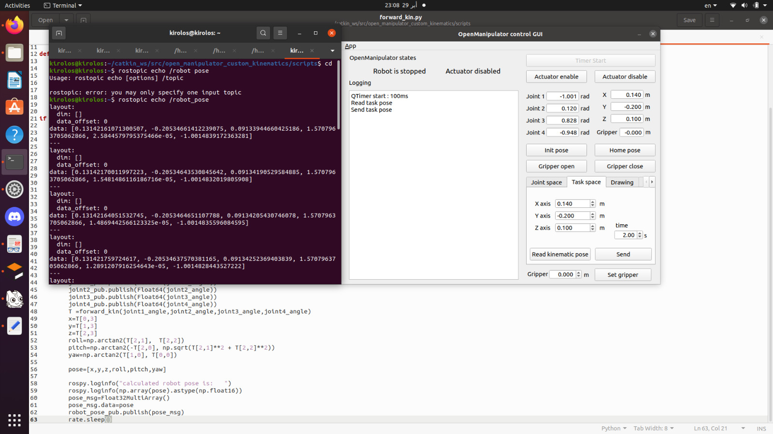a. screenshots of topic echoing of calculated pose after running forward kinematics nodes

Figure 12: topic echoing robot pose

`

b. screenshots for the robot moved inside gazebo after running your inverse kinematics node.

Figure 13: robot after published the required position

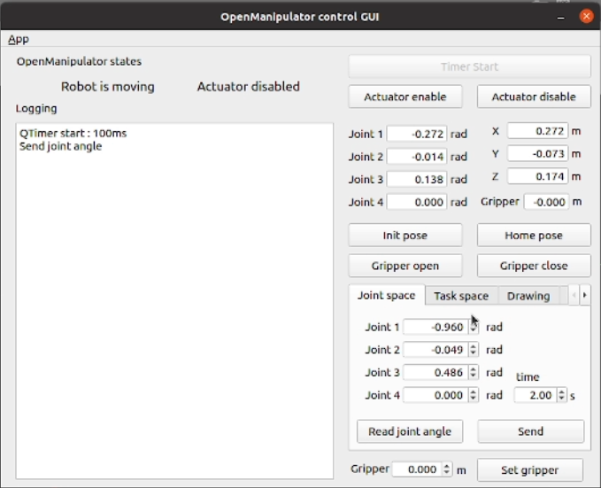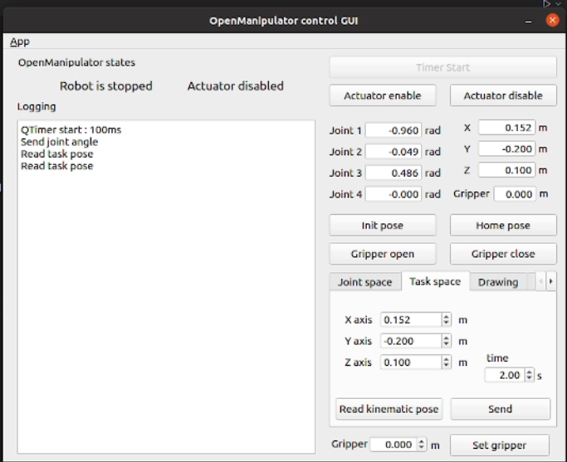c. screenshots of moving the robot using GUI controller and verifying your calculations

Figure :reading the position to compare with the target position node.

Figure 15: sending the calculated angles from the ikine node.

# RQT Graph:

Figure 16: RQT graph

# Links: In this [link](https://drive.google.com/file/d/1_o0NkUGqp1O_4drJVyeFqfuLC7N06ZSd/view?usp=share_link), you will find our video for this milestone.

In this [link](https://drive.google.com/drive/folders/1UTE6ygVSai2y7VsoYW00nMpmQ7rUxL3z?usp=share_link), you will find our data for this milestone.

# References:

[OpenMANIPULATOR-X (robotis.com)](https://emanual.robotis.com/docs/en/platform/openmanipulator_x/overview/)